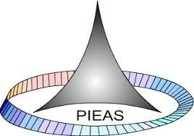

PAKISTAN INSTITUTE OF ENGINEERING AND APPLIED SCIENCES

***Computing Fundamentals & Programming***

**FALL 2020**

Laboratory Exercise: 07

Name: Umar Shifaqat

Department: DPAM

Roll No. BS-20-GB-100864

Date: NOV 07, 2020

**WITH IN LAB TASKS**

**WITH IN LAB TASK 01**

**INPUT**

#include<stdio.h>

int main()

{

int i,num=1;

while(num<=5)

{

for(i=0;i<num;i++)

printf("%d",num);

printf("\n");

num++;

}

getchar();

return 0;

}

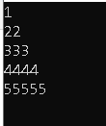

**WITH IN LAB TASK 02**

**INPUT**

#include<stdio.h>

int main()

{

int i,j,k;

for(i=1;i<=5;i++)

{

for(j=1;j<=i;j++)

printf(" %d ",j);

printf("\n");

}

for(i=4;i>0;i--)

{

for(k=1;k<=i;k++)

printf(" %d ",k);

printf("\n");

}

getchar();

return 0;

}

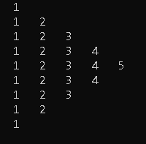

**WITH IN LAB TASK 03**

**INPUT**

#include<stdio.h>

int main()

{

int i,j,k;

for(i=0;i<=5;i++)

{

for(j=0;j<i;j++)

printf(" * ");

printf("\n");

}

for(i=1;i<5;i++)

{

for(k=5;k>i;k--)

printf(" * ");

printf("\n");

}

getchar();

return 0;

}

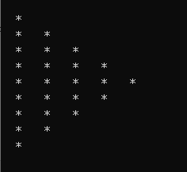

**WITH IN LAB TASK 04**

**INPUT**

#include<stdio.h>

int main()

{

int i=1,num=1,N;

printf("Enter the value of N: ");

scanf("%d",&N);

while(i<=N)

{ printf("\t%d",num);

num+=(num+1);

i++;

}

getchar();

getchar();

getchar();

return 0;

}

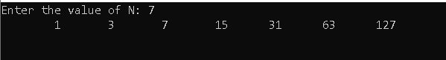

**WITH IN LAB TASK 05**

**INPUT**

#include<stdio.h>

int main()

{

int term1=0,term2=1,term,num,i;

printf("\n\n\t\tNumber of Terms to Display: ");

scanf("%d",&num);

printf("\n\tFabonaci series upto %d terms is : ",num);

for(i=0;i<num;i++)

{

printf(" %d ",term1);

term=term2+term1;

term1=term2;

term2=term;

}

getchar();

getchar();

getchar();

return 0;

} 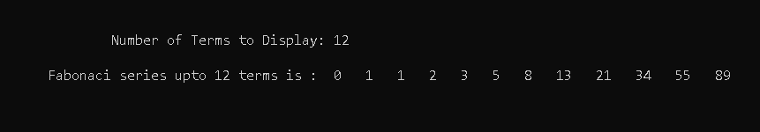

**WITH IN LAB TASK 06**

**INPUT**

#include<stdio.h>

#include<math.h>

int main()

{

int n,i;

double x,sum=0,value;

printf("Enter the Number of terms: ");

scanf("%d",&n);

for(i=1;i<=n;i++)

{ printf("Enter the value of x%d: ",i);

scanf("%lf",&x);

value=log(x);

sum+=value;

}

printf("The sum of series is %lf",sum);

getchar();

getchar();

getchar();

return 0;

}

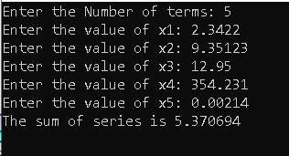

**WITH IN LAB TASK 07**

**INPUT**

#include<stdio.h>

int main()

{

int i,j,k,n;

printf("\n\t\tEnter the value of n:");

scanf("%d",&n);

for(i=0;i<n;i++)

{

for(k=0;k<i;k++)

printf(" ");

for(j=n;j>i;j--)

printf("*");

printf("\n");

}

for(i=2;i<=n;i++)

{

for(j=n;j>i;j--)

printf(" ");

for(k=0;k<i;k++)

printf("*");

printf("\n");

}

getchar();

getchar();

getchar();

return 0;

}

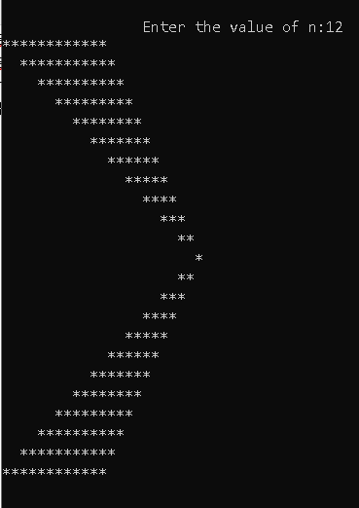

**WITH IN LAB TASK 08**

**INPUT**

#include<stdio.h>

#include<math.h>

int main()

{

int i,j,n,fact,sign=1;

float x,p,sum=0;

printf("Enter the value of (in degrrees) : ");

scanf("%f",&x);

x*=3.14159/180;

printf("Enter the value of n : ");

scanf("%d",&n);

for(i=1;i<=n;i+=2)

{

fact=1;

for(j=1;j<=i;j++)

fact=fact*j;

p=pow(x,i);

sum+=sign*p/fact;

sign=-1*sign;

}

printf("sin %0.2f degrees = %f", x*180/3.14159,sum);

getchar();

getchar();

getchar();

return 0;

}

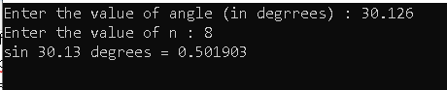

**WITH IN LAB TASK 09**

**INPUT**

#include<stdio.h>

int main()

{

int i,j=1,k,l,n;

float x,y,term,sum=0;

printf("\n\t\tEnter the total number of terms: ");

scanf("%d",&n);

for(i=1;i<=n;i++,j+=2)

{

x=1.0,y=1.0;

for(k=0;k<2;k++)

x*=j;

for(l=0;l<3;l++)

y*=j;

term=x/y;

sum+=term;

}

printf("\n\n\t\tSum of the series is : %f",sum);

getchar();

getchar();

getchar();

return 0;

}

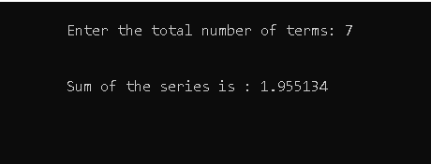

**WITH IN LAB TASK 10**

**INPUT**

#include<stdio.h>

int main()

{

int i,j,n;

printf("Enter the Number of Rows: ");

scanf("%d",&n);

while(n%2==0)

{ printf("You have entered Even Number. Eneter an ODD number.\n");

printf(" Enter the Number of Rows: ");

scanf("%d",&n);

}

for(i=1;i<=n;i++)

{

for(j=n;j>=1;j--)

(j<i)?printf(" "):printf("*");

for(j=1;j<=n;j++)

(j<i)?printf(" "):printf("*");

printf("\n");

}

for(i=n;i>=1;i--)

{

for(j=n;j>=1;j--)

(j<i)?printf(" "):printf("*");

for(j=1;j<=n;j++)

(j<i)?printf(" "):printf("*");

printf("\n");

}

getchar();getchar();getchar();

getchar();

return 0;

}

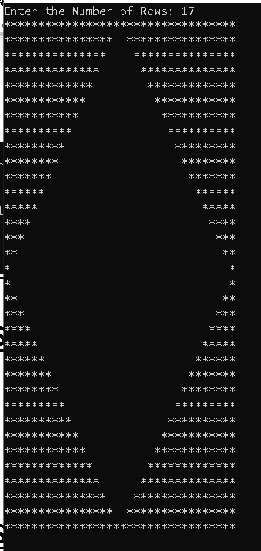

**WITH IN LAB TASK 11**

**(1)**

**INPUT**

#include<stdio.h>

int main()

{

int i,j;

for(i=5;i>=1;i--)

{

for(j=5;j>=i;j--)

printf(" *");

printf("\n");

}

getchar();

return 0;

}

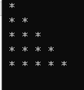

**(2)**

**INPUT**

#include<stdio.h>

int main()

{

int i,j;

for(i=5;i>=1;i--)

{

for(j=1;j<=5;j++)

(j<i)?printf(" "):printf(" *");

printf("\n");

}

getchar();

getchar();

return 0;

}

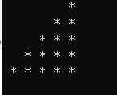

**(3)**

**INPUT**

#include<stdio.h>

int main()

{

int i,j;

for(i=5;i>=1;i--)

{

for(j=1;j<=5;j++)

(j<i)?printf(" "):printf(" *");

for(j=4;j>=1;j--)

(j<i)?printf(" "):printf(" *");

printf("\n");

}

getchar();

getchar();

return 0;

}

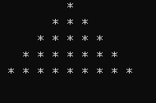

**(4)**

**INPUT**

#include<stdio.h>

int main()

{

int i,j;

for(i=1;i<=5;i++)

{

for(j=1;j<=5;j++)

(j<i)?printf(" "):printf(" *");

printf("\n");

}

getchar();

getchar();

return 0;

}

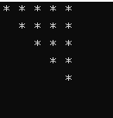

**(5)**

**INPUT**

#include<stdio.h>

int main()

{

int i,j;

for(i=1;i<=5;i++)

{

for(j=5;j>=1;j--)

(j<i)?printf(" "):printf(" *");

printf("\n");

}

getchar();

getchar();

return 0;

}

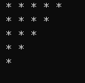

**(6)**

**INPUT**

#include<stdio.h>

int main()

{

int i,j;

for(i=1;i<=5;i++)

{

for(j=1;j<=5;j++)

(j<i)?printf(" "):printf(" *");

for(j=5;j>=0;j--)

(j<=i)?printf(" "):printf(" *");

printf("\n");

}

getchar();

getchar();

return 0;

}

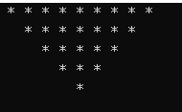

**HOME TASKS**

**HOME TASK 01**

**INPUT**

#include<stdio.h>

int main()

{

int a,b;

printf("\n");

for(a=5;a>=1;a--)

{

for(b=1;b<=a;b++)

printf(" %d ",b);

printf("\n");

}

for(a=2;a<=5;a++)

{

for(b=1;b<=a;b++)

printf(" %d ",b);

printf("\n");

}

getchar();

return 0;

}

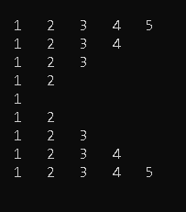

**HOME TASK 02**

**INPUT**

#include<stdio.h>

int main()

{

int i,j,n,fact,sign=1;

float x,p,sum=1;

printf("Enter Value of angle(in degrees):");

scanf("%f",&x);

x*=3.1415/180;

printf("Enter Value of n: ");

scanf("%d",&n);

for(i=2;i<=n;i+=2)

{

p=1;

fact=1;

for(j=1;j<=i;j++)

{

p=p*x;

fact=fact*j;

}

sign=-1*sign;

sum+=sign*p/fact;

}

printf("\n\tcos %0.2f degree = %f",x *180/3.1415,sum);

getchar();

getchar();

getchar();

return 0;

}

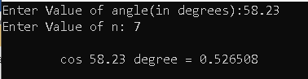

**HOME TASK 03**

**INPUT**

#include<stdio.h>

int main()

{

int n,num=1,i,j,k;

printf("Enter the number of rows: ");

scanf("%d",&n);

for(i=0;i<n;i++)

{

for(j=1;j<=n-i;j++)

printf(" ");

for(k=0;k<=i;k++)

{

(k==0||i==0)?num=1:num=num*(i-k+1)/k;

printf("%4d",num);

}

printf("\n");

}

getchar();

getchar();

getchar();

return 0;

}

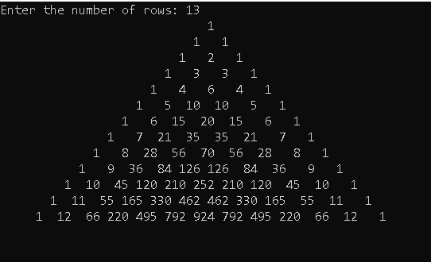

**HOME TASK 04**

**INPUT**

#include<stdio.h>

int main()

{

int i,j,x,N;

printf("enter the number of rows: ");

scanf("%d",&N);

for(i=1;i<=N;i++)

{

for(x=2;x<=i;x++)

printf(" ");

printf("%d",i);

for(j=N;j>i;j--)

printf(" ");

for(j=N;j>i;j--)

printf(" ");

printf("%d",i);

if(i==N)

printf("\b ");

for(x=2;x<=i;x++)

printf(" ");

printf("\n");

}

for(i=N-1;i>=1;i--)

{

for(x=2;x<=i;x++)

printf(" ");

printf("%d",i);

for(j=N-1;j>=i;j--)

printf(" ");

for(j=N-1;j>=i;j--)

printf(" ");

printf("%d",i);

for(x=2;x<=i;x++)

printf(" ");

printf("\n");

}

getchar();

getchar();

getchar();

return 0;

}

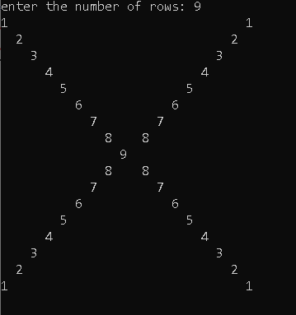

**HOME TASK 05**

**INPUT**

#include<stdio.h>

int main()

{

int n,i,j,num;

printf("Enter the Value of N: ");

scanf("%d",&n);

for(i=1;i<=n;i++)

{

for(j=1;j<=n;j++)

(j>=i)?printf(" %d",num=2*j-1):i=i;

printf("\n");

}

getchar();

getchar();

getchar();

return 0;

}

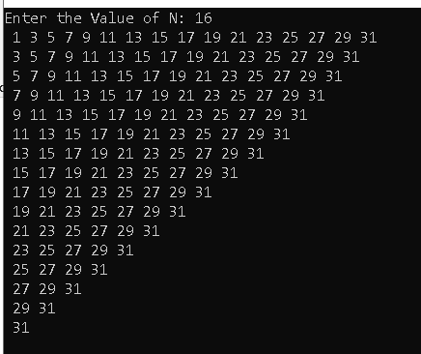

**HOME TASK 06**

**INPUT**

#include<stdio.h>

int main()

{

int i,j,n,num=1,sign=1;

printf("Enter the value of N: ");

scanf("%d",&n);

for(i=0;i<n;i++)

{

for(j=0;j<=i;j++)

printf("%d",num);

sign=-sign;

num+=sign;

printf("\n");

}

getchar();

getchar();

getchar();

return 0;

}

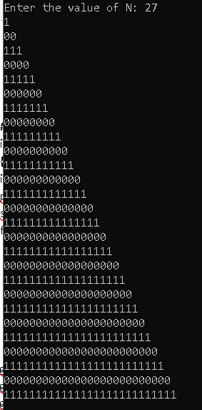

**HOME TASK 07**

**INPUT**

#include<stdio.h>

int main()

{

int i,k,j,n;

printf("Enter the vale of n:");

scanf("%d",&n);

for(i=1;i<=n;i++)

{

for(j=1;j<=n;j++)

(j>i)? printf(" "):printf("%d",j);

for(j=n;j>=1;j--)

(j>i)? printf(" "):printf("%d",j);

printf("\n");

}

getchar();

getchar();

getchar();

return 0;

}

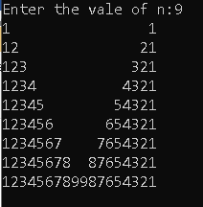

**HOME TASK 08**

**INPUT**

#include<stdio.h>

int main()

{

int i,j,rows,num=1,add=1;

printf("Enter the no. of Rows: ");

scanf("%d",&rows);

for(i=0;i<rows;i++)

{

for(j=0;j<=i;j++)

{

printf("\t%d",num);

num+=add;

add++;

}

printf("\n");

}

getchar();

getchar();

getchar();

return 0;

}

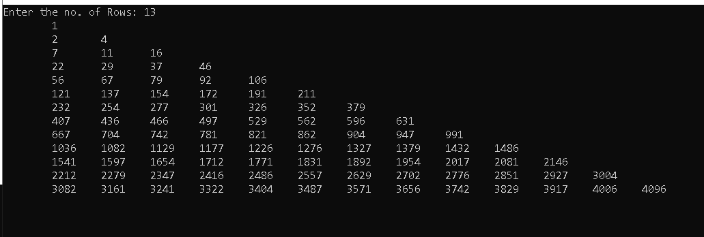

**HOME TASK 09**

**INPUT**

#include<stdio.h>

int main()

{

int i,j;

printf("*\n");

for(i=1;i<=9;i++)

{

printf("*");

for(j=1;j<i;j++)

printf(" %d",j);

for(;j>=1;j--)

printf(" %d",j);

printf("*\n");

}

for(i=7;i>=0;i--)

{

printf("*");

for(j=1;j<=i;j++)

printf(" %d",j);

for(;j>=1;j--)

printf(" %d",j);

printf("*\n");

}

printf("*\n");

getchar();

getchar();

return 0;

}

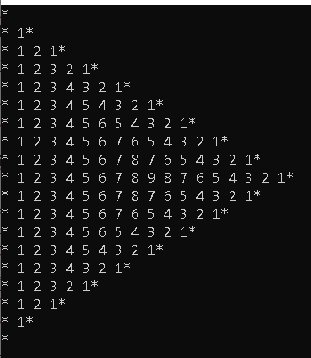

**HOME TASK 10**

**INPUT**

#include<stdio.h>

int main()

{

int i,j,n,fact;

float x,p,sum=1;

printf("Enter Value of x:");

scanf("%f",&x);

printf("Enter Value of n: ");

scanf("%d",&n);

for(i=1;i<=n;i++)

{

p=1;

fact=1;

for(j=1;j<=i;j++)

{

p=p*x;

fact=fact*j;

}

sum+=p/fact;

}

printf("\n\t%f",sum);

getchar();

getchar();

getchar();

return 0;

}

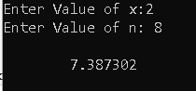

**HOME TASK 11**

**INPUT**

#include<stdio.h>

int main()

{

int i,j;

for(i=10;i>=1;i--)

{

for(j=1;j<=10;j++)

(j<i)?printf(" "):printf(" *");

for(j=9;j>=1;j--)

(j<i)?printf(" "):printf(" *");

printf("\n");

}

for(i=2;i<=10;i++)

{

for(j=1;j<=10;j++)

(j<i)?printf(" "):printf(" *");

for(j=10;j>=0;j--)

(j<=i)?printf(" "):printf(" *");

printf("\n");

}

getchar();

getchar();

return 0;

}

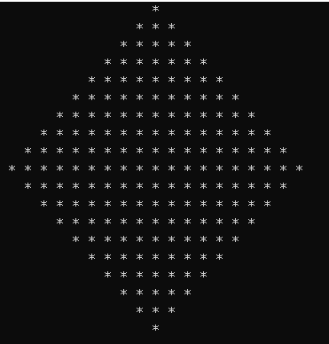

**HOME TASK 12**

**INPUT**

#include<stdio.h>

int main()

{

char i,j;

for(i='J';i>='A';i--)

{

for(j='A';j<='J';j++)

(j<=i)?printf(" %c",j):printf(" ");

j--;j--;

for(;j>='A';j--)

(j<=i)?printf(" %c",j):printf(" ");

printf("\n");

}

getchar();

return 0;

}

